Grand Canyon Geology
Video Worksheet

Today, you are the investigator looking for evidence that explains how the Grand Canyon landscape was formed! As you explore Grand Canyon, use this worksheet to take notes of the pieces of evidence that you find. By the end of this video, you will have discovered evidence explain the forces that shape the Grand Canyon landscape.

Directions: Answer the following questions on this worksheet as you watch the video. The video will have built in pause points that give you time to answer the questions.

Worksheet Pause 1
What I Know.
Based on what you know, what forces do you think are shaping Grand Canyon?

What I Want to Know.
What do you want to know about the forces that shape Grand Canyon?

*Revisit this question, at the last pause of the video
Worksheet Pause 6
What I Learned.
After you discovered evidence of the forces that shape Grand Canyon, write about what you learned. What force was the most interesting? What did that force do to shape the Canyon?

Worksheet Pause 2 – Small Evidence
Green/orange crust on rock | Small craters in rock | Chert lump in rock
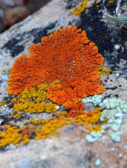 | 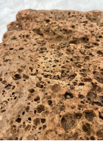 | 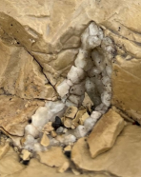
How does this evidence shape Grand Canyon? | How does this evidence shape Grand Canyon? | How does this evidence shape Grand Canyon?

Worksheet Pause 3 – Big Evidence
Red rust on rock | Rock Tower | Side Canyons
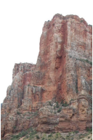 | 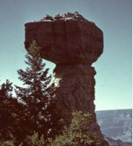 | 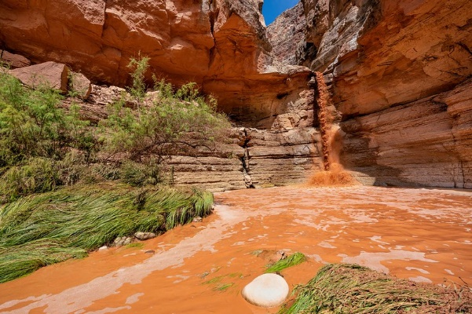
How does this evidence shape Grand Canyon? | How does this evidence shape Grand Canyon? | How does this evidence shape Grand Canyon?

Worksheet Pause 4 – Human Evidence
Recreation - Trails | Transportation – Vehicles/Mules | Land Development - Damns
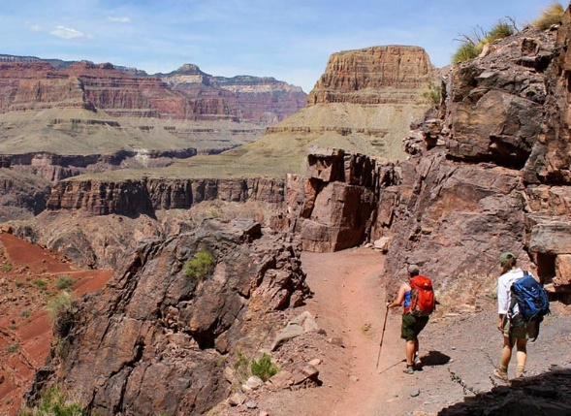 | 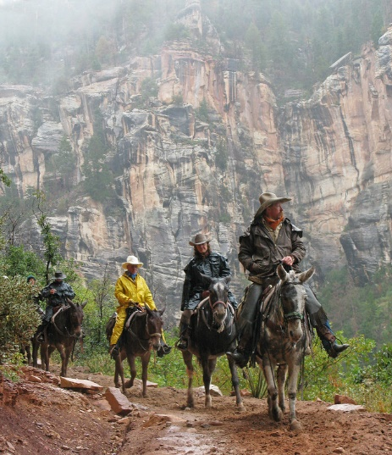 | 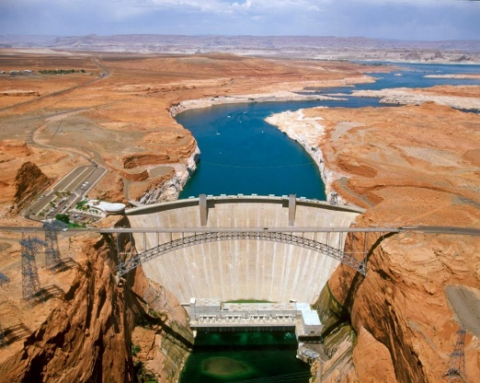
How does this evidence shape Grand Canyon? | How does this evidence shape Grand Canyon? | How does this evidence shape Grand Canyon?

Worksheet Pause 5 – River Evidence
Slope | Force | Dry Environment
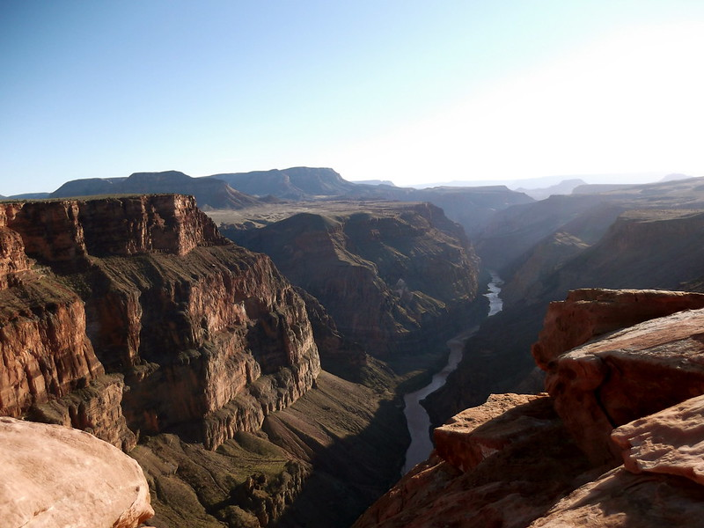 | 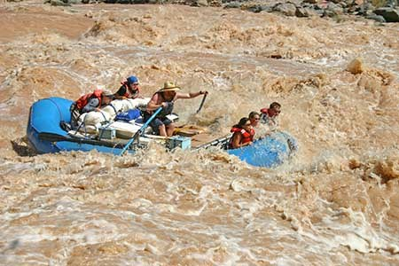 | 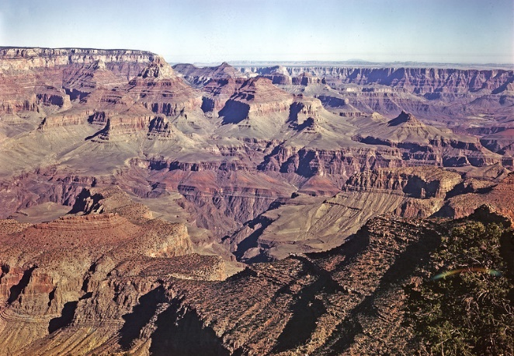
How does this evidence shape Grand Canyon? | How does this evidence shape Grand Canyon? | How does this evidence shape Grand Canyon?

Worksheet Pause 6 – Return to the first page and complete the “What I Learned” section.

